

**O’ZBEKISTON RESPUBLIKASI MAKTABGACHA VA MAKTAB TA’LIMI VAZIRLIGI**

**NIZOMIY NOMIDAGI TOSHKENT DAVLAT PEDAGOGIKA UNIVERSITETI**

**BOSHLANG’ICH TA’LIM FAKULTETI**

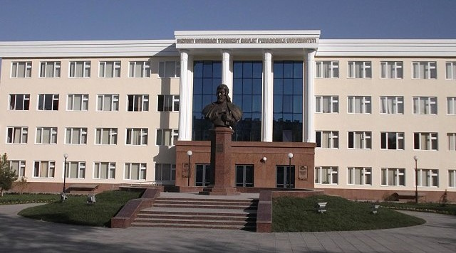

**MUSTAQIL ISH**

**Fan:________________________________________________________________________________________________________________________________________________**

**Mavzu:______________________________________________________________________________________________________________________________________________**

**Tekshirdi:____________________________________________**

**Bajardi:______________________________________________**

**TOSHKENT 2025**